First Challenge
- Launch one EC2 instance using Amazon Linux.
- Install Docker.
- Install Jenkins.
- Install Apache.
- Install Nginx.
- Install Apache Tomcat.
Everything needs to be setup and running on the same EC2.
You can change the port numbers as required.
We can install all of them on a single Amazon Linux 2 EC2 instance. Since Apache, Nginx, Tomcat, and Jenkins all use web ports, we must assign different ports to avoid conflicts.
A common configuration is:
Service | Port
Apache (httpd) | 80
Nginx | 81
Tomcat | 8080
Jenkins | 8081

Launch EC2
- AMI: Amazon Linux 2023
- Instance Type: t3.micro
- Security Group:
  - SSH (22)
  - HTTP (80)
  - Custom TCP (81)
  - Custom TCP (8080)
  - Custom TCP (8081)
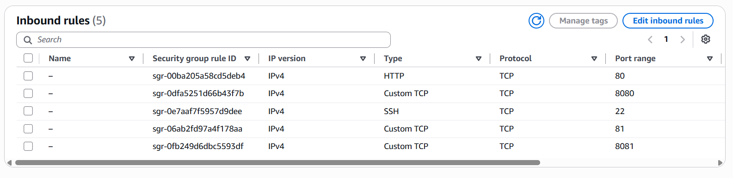
Connect:
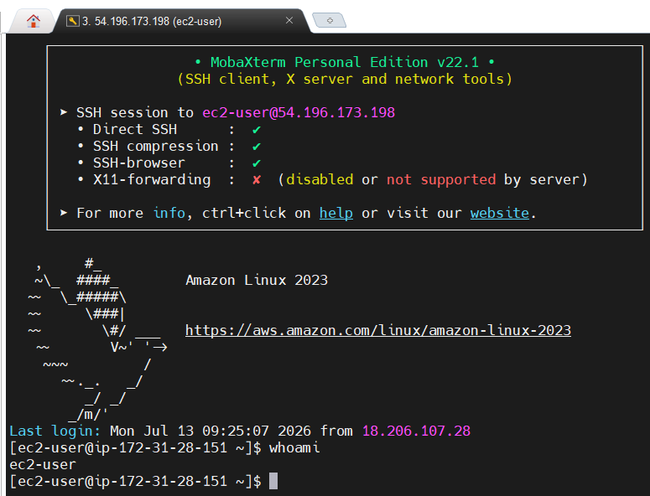

Step 1: Update the System
sudo dnf update -y
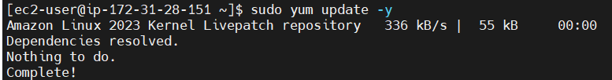

Step 2: Install Java
Java is required for Jenkins and Tomcat.
sudo dnf install java-21-amazon-corretto -y
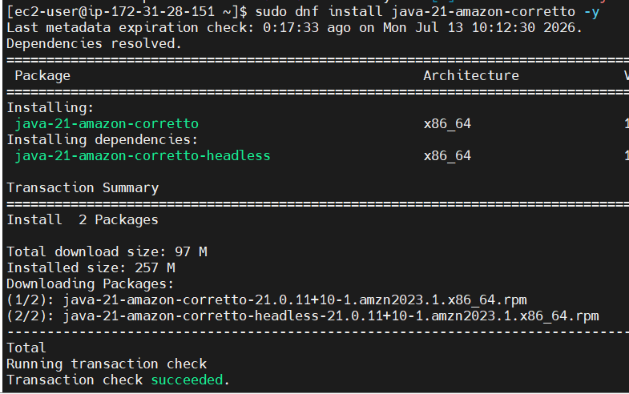
Verify Java:
java -version
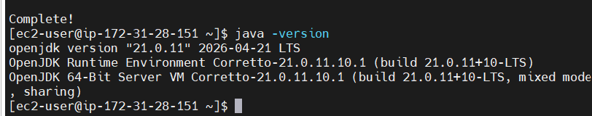

Step 3: Install Docker
Install Docker:
sudo dnf install docker -y
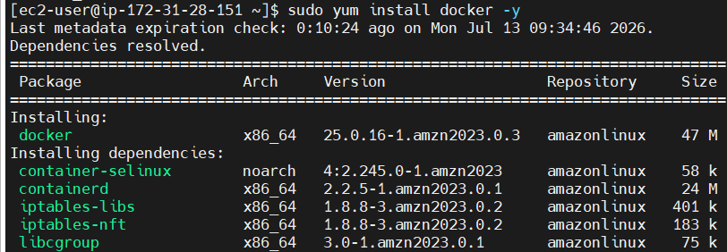
Start Docker:
sudo systemctl start docker
Enable Docker:
sudo systemctl enable docker
Add the ec2-user to the Docker group:
sudo usermod -aG docker ec2-user
Verify Docker:
docker –version
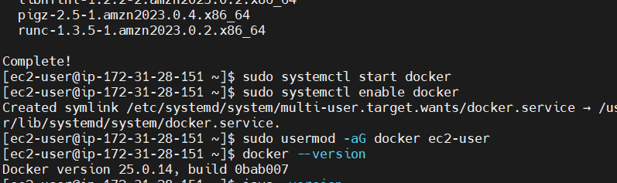

Step 4: Install Jenkins
Add the Jenkins repository:
sudo wget -O /etc/yum.repos.d/jenkins.repo https://pkg.jenkins.io/redhat-stable/jenkins.repo
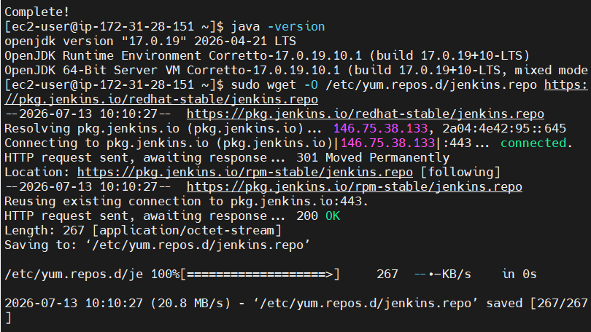
Import the Jenkins key:
sudo rpm --import https://pkg.jenkins.io/redhat-stable/jenkins.io-2023.key
Install Jenkins:
sudo dnf install jenkins -y
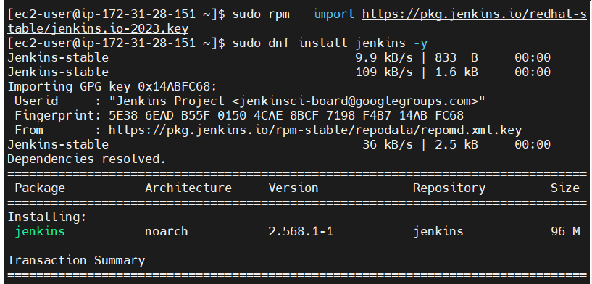
Change Jenkins port from 8080 to 8081:
sudo vi /usr/lib/systemd/system/jenkins.service
Find:
Environment="JENKINS_PORT=8080"
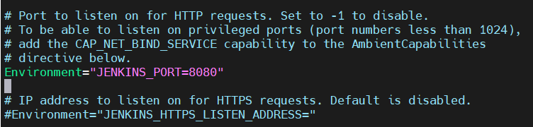
Change to:
Environment="JENKINS_PORT=8081"
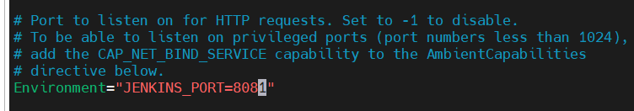
Reload systemd:
sudo systemctl daemon-reload
Enable and start Jenkins:
sudo systemctl enable jenkins
sudo systemctl start jenkins
Check status:
sudo systemctl status Jenkins
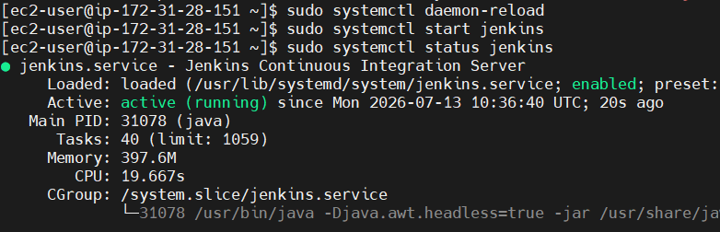
Get the initial admin password:
sudo cat /var/lib/jenkins/secrets/initialAdminPassword
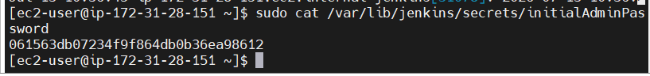
Access Jenkins:
http://<Public-IP>:8081
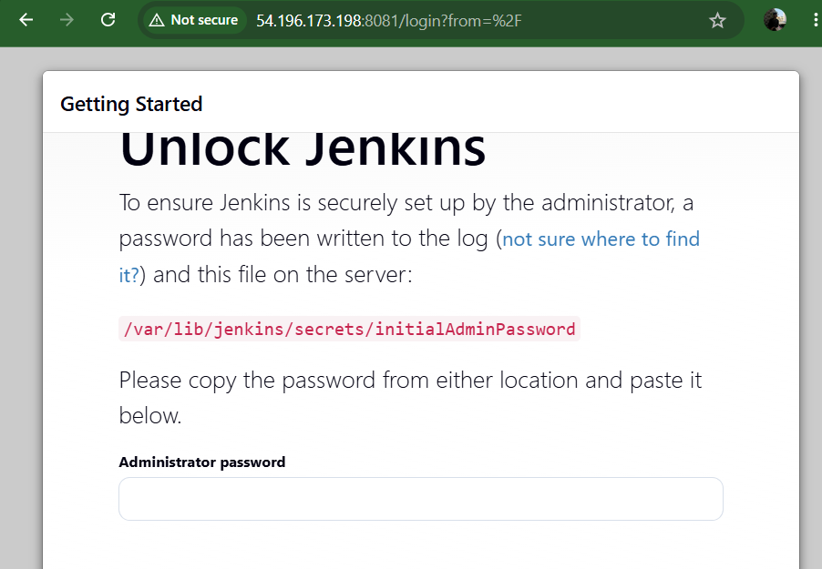

Step 5: Install Apache
Install Apache:
sudo dnf install httpd -y
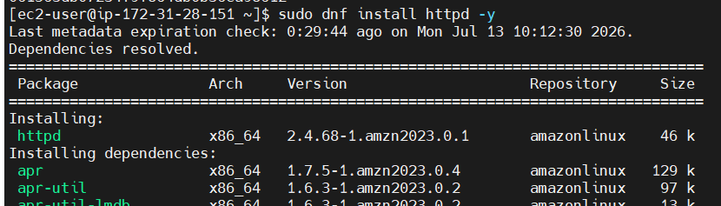
Enable and start Apache:
sudo systemctl enable httpd
sudo systemctl start httpd
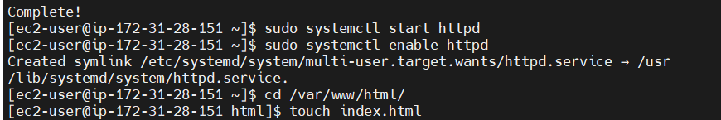
Create a sample web page:
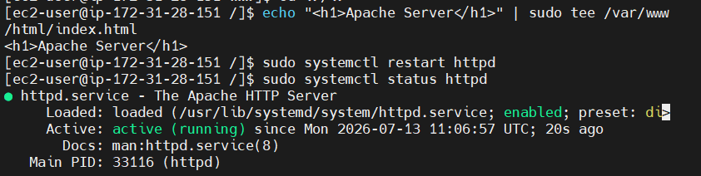
Verify:
http://<Public-IP>
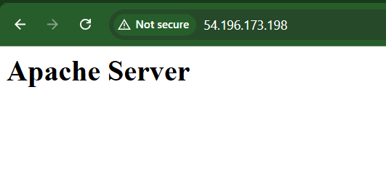

Step 6: Install Nginx
Install Nginx:
sudo dnf install nginx -y
Edit the configuration:
sudo vi /etc/nginx/nginx.conf
Change:
listen 80;
to
listen 81;
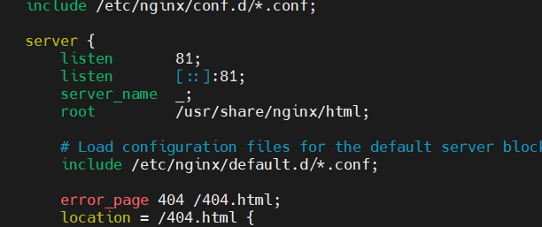
Enable and start Nginx:
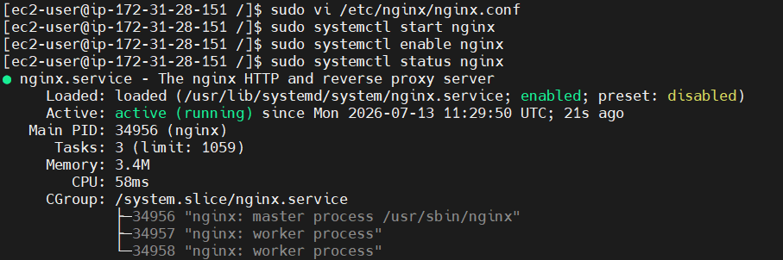
sudo systemctl enable nginx
sudo systemctl start nginx
Verify:
http://<Public-IP>:81
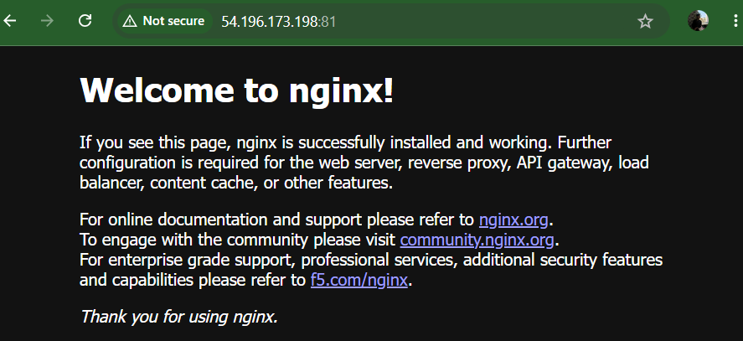

Step 7: Install Apache Tomcat
Go to the /opt directory:
cd /opt
Download Tomcat:
sudo wget https://downloads.apache.org/tomcat/tomcat-10/v10.1.57/bin/apache-tomcat-10.1.57.tar.gz
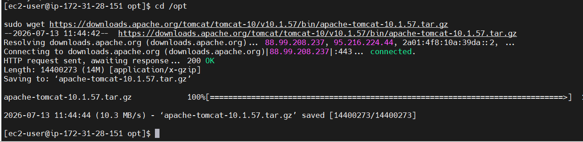Extract the archive:
sudo tar -xzf apache-tomcat-10.1.57.tar.gz
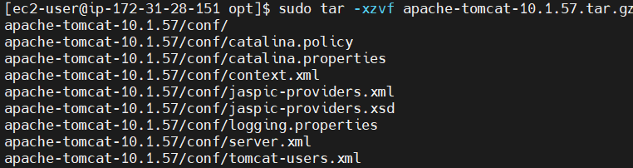
Rename the directory:
sudo mv apache-tomcat-10.1.57 tomcat
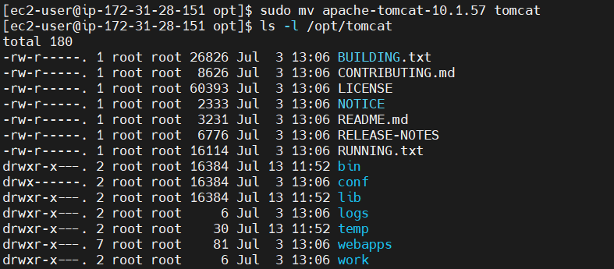
Give execute permission:
sudo chmod +x /opt/tomcat/bin/*.sh
Start Tomcat:
sudo /opt/tomcat/bin/startup.sh
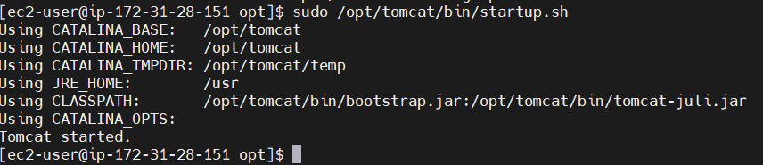
Verify:
http://<Public-IP>:8080
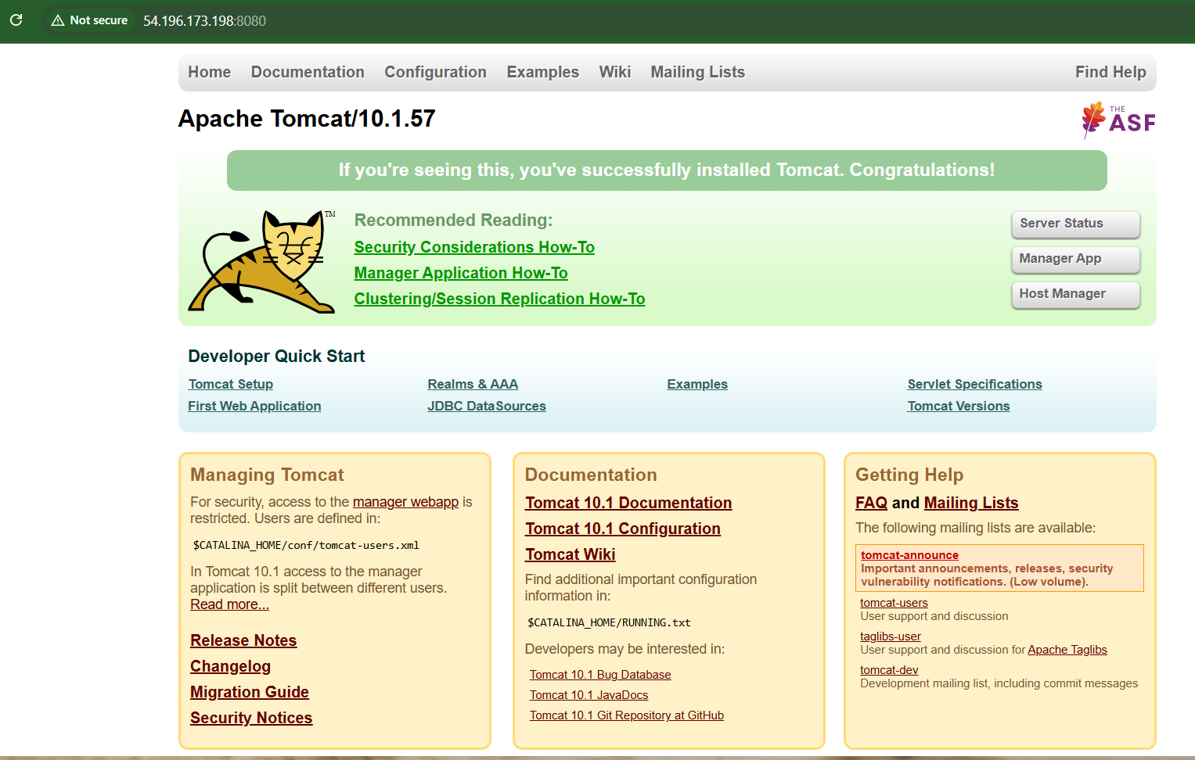

Check listening ports:
ss -tuln
Expected ports:
Service | Port
Apache | 80
Nginx | 81
Tomcat | 8080
Jenkins | 8081
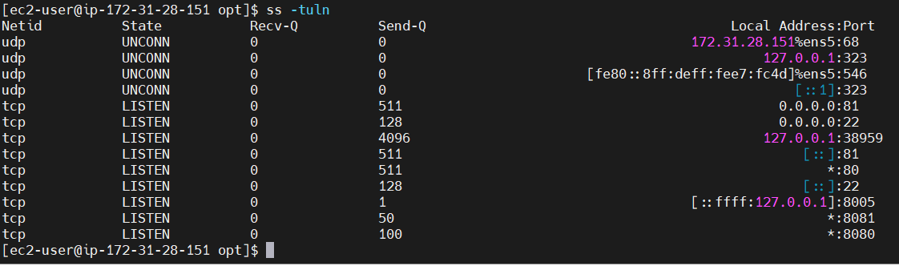

Final URLs
- Apache: http://54.196.173.198:80
- Nginx: http://54.196.173.198:81
- Tomcat: http://54.196.173.198:8080
- Jenkins: http://54.196.173.198:8081
This setup allows all services to run simultaneously on the same Amazon Linux 2 EC2 instance without port conflicts.

